Calvin Suratos

CPE301 – SPRING 2016

Design Assignment 5

**DO NOT REMOVE THIS PAGE DURING SUBMISSION:**

The student understands that all required components should be submitted in complete for grading of this assignment.

|  |  |  |  |
| --- | --- | --- | --- |
| **NO** | **SUBMISSION ITEM** | **COMPLETED (Y/N)** | **MARKS**  **(/MAX)** |
| 0. | COMPONENTS LIST AND CONNECTION BLOCK DIAGRAM w/ PINS |  |  |
| 1. | INITIAL CODE OF TASK 1/A |  |  |
| 2. | INCREMENTAL / DIFFERENTIAL CODE OF TASK 2/B |  |  |
| 3. | INCREMENTAL / DIFFERENTIAL CODE OF TASK 3/C |  |  |
| 4. | SCHEMATICS |  |  |
| 5. | SCREENSHOTS OF EACH TASK OUTPUT |  |  |
| 6. | SCREENSHOT OF EACH DEMO |  |  |
| 7. | VIDEO LINKS OF EACH DEMO |  |  |
| 8. | GOOGLECODE LINK OF THE DA |  |  |
|  |  |  |  |
|  |  |  |  |

|  |  |  |  |
| --- | --- | --- | --- |
| 0. | COMPONENTS LIST AND CONNECTION BLOCK DIAGRAM w/ PINS |  |  |

Breadboard

Jumper Wires

Atmega328P

Pololu USB AVR programmer

10K potentiometer

DC Motor

Stepper Motor

Servo Motor

* 1. uF capacitor

ULN2003

|  |  |  |  |
| --- | --- | --- | --- |
| 1. | INITIAL CODE OF TASK 1/A |  |  |

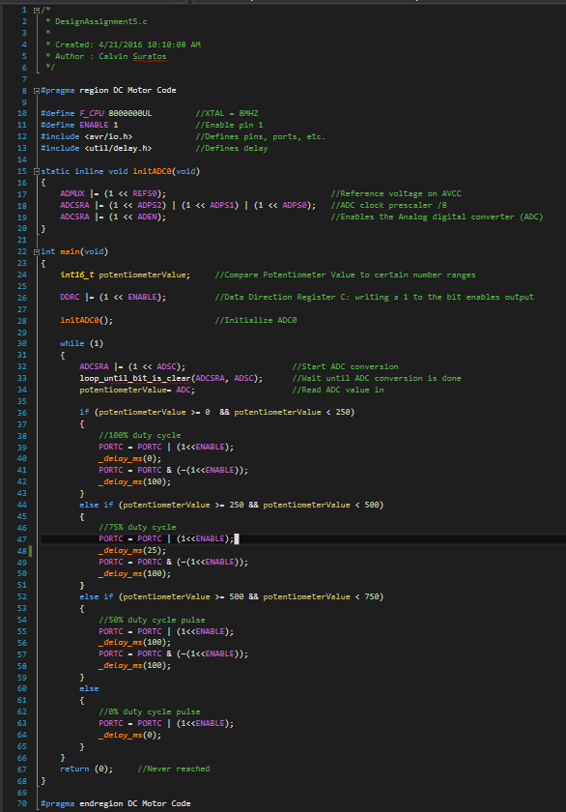

|  |  |  |  |
| --- | --- | --- | --- |
| 2. | INCREMENTAL / DIFFERENTIAL CODE OF TASK 2/B |  |  |

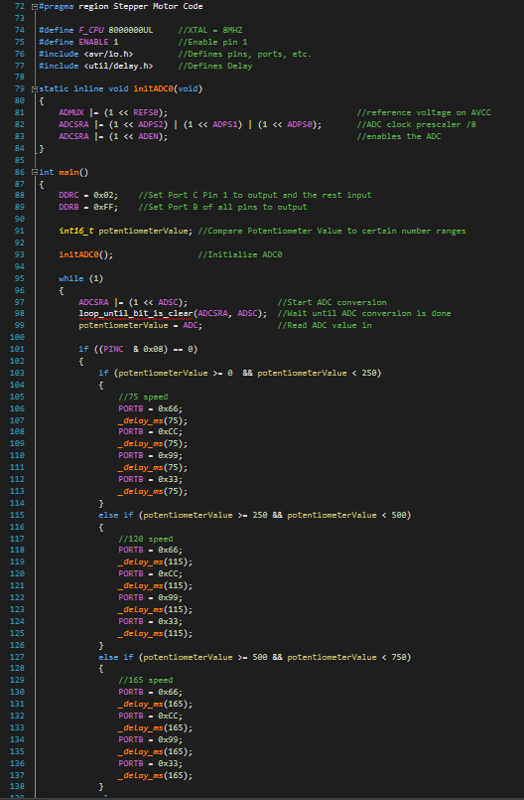

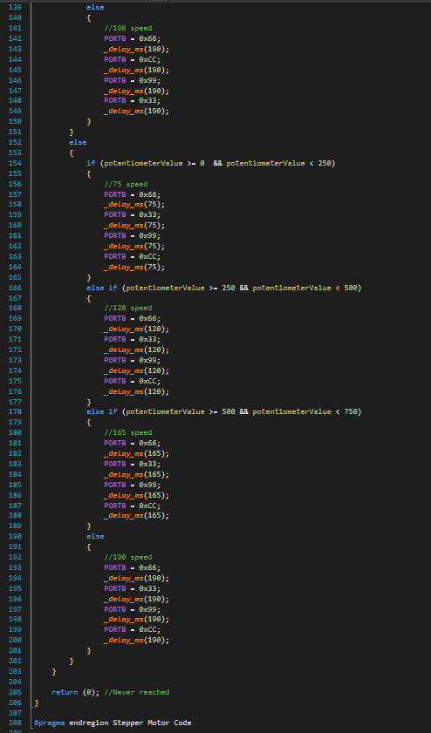

|  |  |  |  |
| --- | --- | --- | --- |
| 3. | INCREMENTAL / DIFFERENTIAL CODE OF TASK 3/C |  |  |

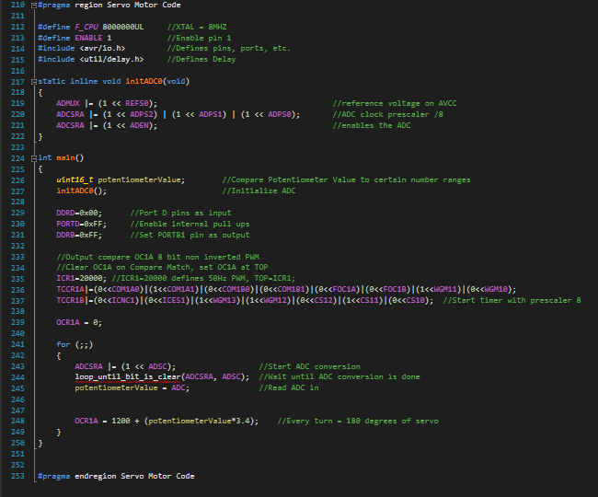

|  |  |  |  |
| --- | --- | --- | --- |
| 4. | SCHEMATICS |  |  |

TASK 1/A: DC Motor Schematic

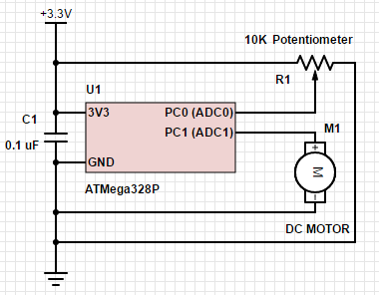

TASK 2/B: Stepper Motor Schematic (PC3 can be 0 or 1 = determines direction)

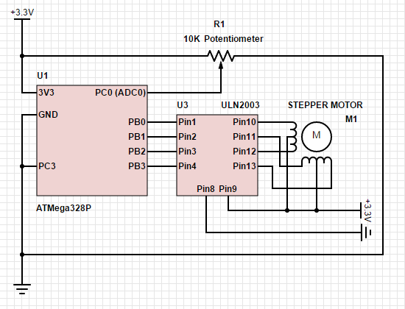

TASK 3/C: Servo Motor Schematic

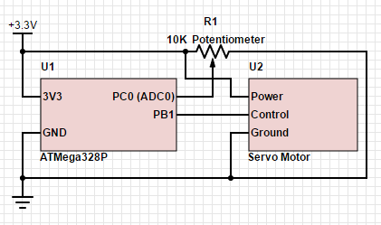

|  |  |  |  |
| --- | --- | --- | --- |
| 5. | SCREENSHOTS OF EACH TASK OUTPUT |  |  |

TASK 1/A: See video link of the task output for DC Motor.

TASK 2/B: See video link of the task output for Stepper Motor.

TASK 3/C: See video link of the task output for Servo Motor.

|  |  |  |  |
| --- | --- | --- | --- |
| 6. | SCREENSHOT OF EACH DEMO |  |  |

TASK 1/A: Using the potentiometer, it controls the speed of the DC Motor

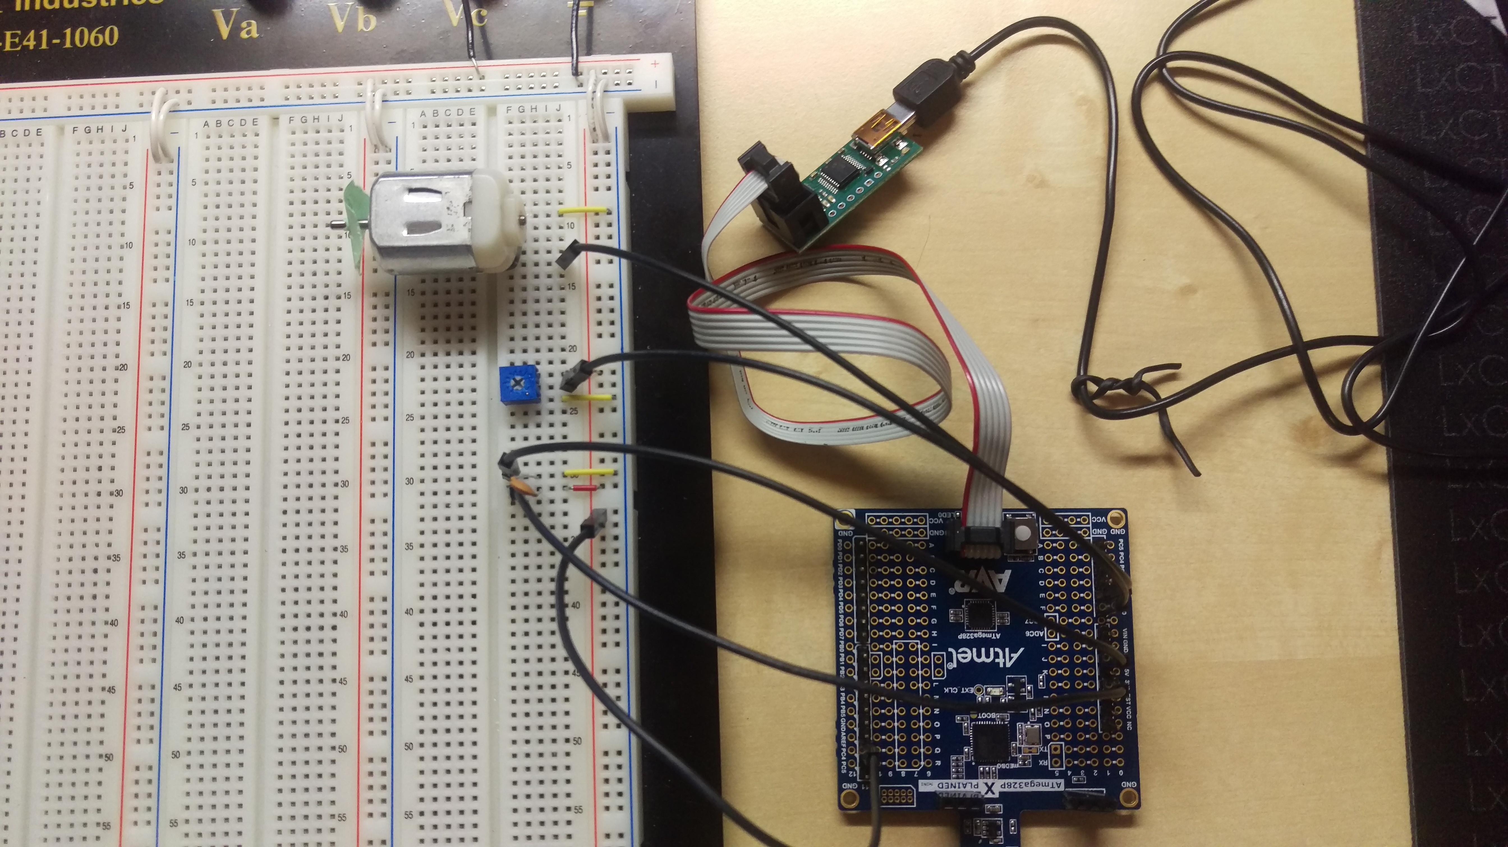

TASK 2/B: Using the potentiometer, it controls the speed of the Stepper Motor. Also, when PINC 3 is 0, then the motor moves clockwise, and when PINC 3 is 1, then the motor moves counter clockwise.

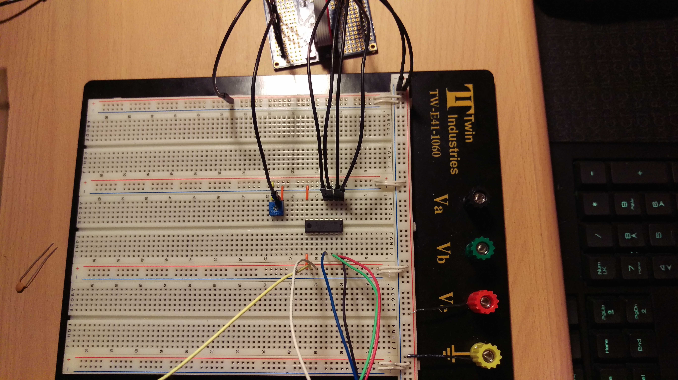

TASK 3/C: Using the potentiometer, it controls the position of the Servo Motor. When the pot value is 0 the motor is at position 0 degrees, and if the pot value is max the motor is at position 180 degrees.

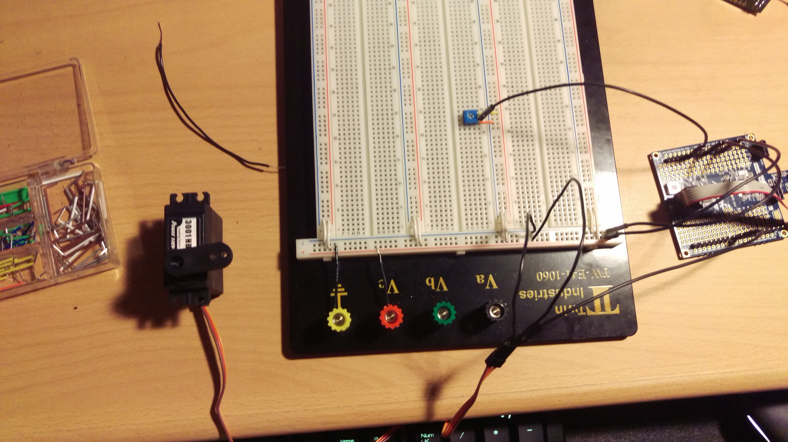

|  |  |  |  |
| --- | --- | --- | --- |
| 9. | VIDEO LINKS OF EACH DEMO |  |  |
| <https://drive.google.com/folderview?id=0B5Kz0gdhFCkDRkd0N1JKaTZxWDQ&usp=sharing> | | | |
| 10. | GOOGLECODE LINK OF THE DA |  |  |
| <https://github.com/CalvinSuratos/DesignAssignments.git> | | | |

**Student Academic Misconduct Policy**

<http://studentconduct.unlv.edu/misconduct/policy.html>

“This assignment submission is my own, original work”.

Calvin Suratos